Optimizing Shipping Costs Without Hurting Profitability


This project investigates how global retail businesses can reduce shipping expenses while maintaining profitability and operational performance. By analyzing shipping methods, costs, discounts, and market behavior within the Global Superstore dataset, the study identifies inefficient operational patterns and proposes data-driven recommendations to improve shipping efficiency without negatively affecting sales or customer satisfaction.

Introduction

Shipping operations play a critical role in the profitability of global retail businesses. While fast delivery methods can improve customer satisfaction, they also generate significant operational expenses that may reduce overall profit margins.
This project analyzes the Global Superstore dataset to explore how shipping costs, shipping methods, discounts, and market performance affect profitability across different international markets.
The main objective of this analysis is to identify inefficient shipping patterns and evaluate whether shipping expenses can be optimized without negatively impacting business performance.
The analysis focuses on answering several key business questions:
- Which shipping methods are the most profitable?
- Do faster shipping methods justify their operational costs?
- Which markets show weak shipping efficiency?
- How do discounts affect profitability?
- What operational patterns contribute to loss-making orders?
By combining exploratory data analysis, profitability analysis, and shipping-efficiency metrics, this project aims to provide business-oriented recommendations for improving operational efficiency while maintaining strong sales performance.

Data Understanding

The dataset contains 51,290 rows and 27 columns representing global retail transactions.
Initial exploration using .shape, .info(), and .columns showed that the dataset includes:
- numerical variables such as Sales, Profit, Quantity, and Shipping Cost,
- categorical variables such as Market, Category, and Ship Mode,
- and date variables including Order Date and Ship Date.
The analysis mainly focuses on the following variables:
Variable | Description
Sales | Total sales amount for the order
Profit | Profit generated from the order
Shipping Cost | Cost associated with shipping
Ship Mode | Shipping method used
Market | Geographical market
Discount | Discount applied to the order
The dataset appears well-structured and suitable for exploratory analysis.

Data Cleaning

Several preprocessing steps were performed to prepare the dataset for analysis.
Missing Values
The dataset was checked for missing values using .isnull().sum().
No missing values were detected.
Duplicate Rows
The dataset was checked for duplicate rows using .duplicated().sum().
No duplicate rows were found.
Column Renaming
The column 记录数 was renamed to Record Count to improve readability and maintain naming consistency.
Date Conversion
The columns Order.Date and Ship.Date were converted to datetime format using pd.to_datetime().
This step enables:
- time-series analysis,
- delivery-time calculations,
- and trend analysis.
The parameter errors='coerce' was used to safely handle invalid date values.

Exploratory Data Analysis (EDA)

The exploratory analysis focused on understanding how shipping operations impact profitability across different markets and shipping methods.
The analysis was divided into three main areas:
1. Shipping Cost Analysis
This section explores:
- shipping expenses across shipping modes,
- shipping efficiency across markets,
- shipping trends over time,
- and shipping cost ratios.
2. Profitability Analysis
This section analyzes:
- profit distribution across shipping methods,
- profit margins,
- and the impact of discounts on profitability.
3. Relationship Between Shipping and Profit
This section investigates the relationship between:
- shipping costs,
- sales,
- and profit
using correlation analysis and visualizations.

Analysis

1. Key Performance Indicators (KPIs)
KPI | Value
Total Sales | 12.64M
Total Profit | 1.47M
Total Shipping Cost | 1.35M
Average Shipping Cost | 26.38

The company generated approximately 12.6 million in total sales and 1.47 million in profit during the analyzed period.
Shipping operations represent a significant operational expense, with total shipping costs exceeding 1.35 million.
The average shipping cost per order is relatively moderate at 26.38, but further analysis is required to determine whether shipping efficiency varies across:
- shipping methods,
- geographical markets,
- and product categories.
These KPIs provide an initial overview of the business performance and establish the foundation for deeper profitability and shipping-cost analysis.

2. Shipping Cost Analysis

Profit by Shipping Mode
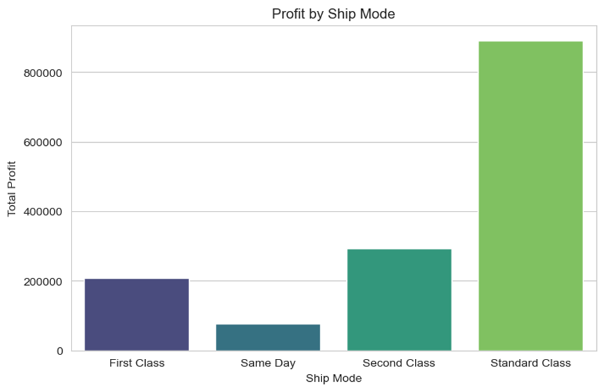

The analysis shows that Standard Class generates the highest total profit among all shipping methods.
This result is largely driven by its significantly higher order volume compared to faster delivery methods.
Although Same Day and First Class shipping offer faster delivery, they generate lower overall profit while incurring higher shipping expenses.
These findings suggest that Standard Class provides a more balanced trade-off between operational cost and profitability.

Profitability Efficiency by Shipping Mode
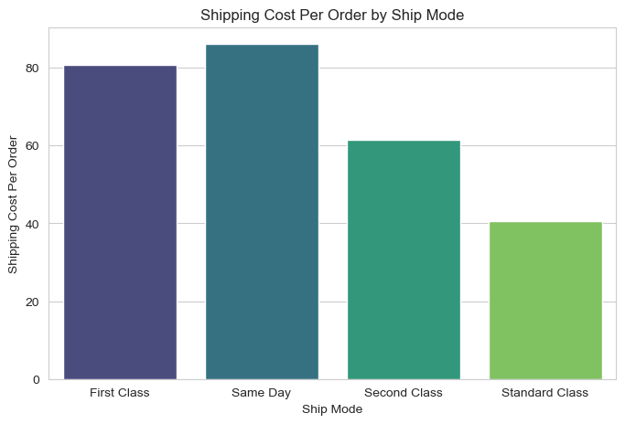
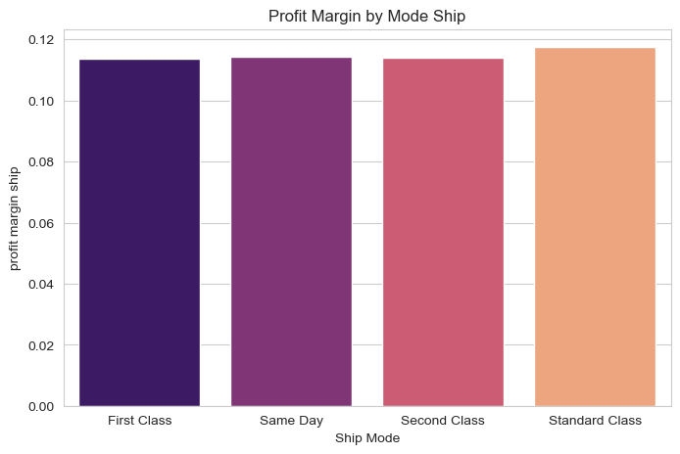To better evaluate shipping efficiency, profitability was analyzed relative to order volume and sales performance.
The results indicate that faster shipping methods tend to produce higher shipping costs per order.
While premium delivery services may improve customer experience, they also increase operational expenses and may reduce profit efficiency.
This highlights the importance of balancing delivery speed with cost optimization.

3. Market Analysis

Shipping Cost by Market
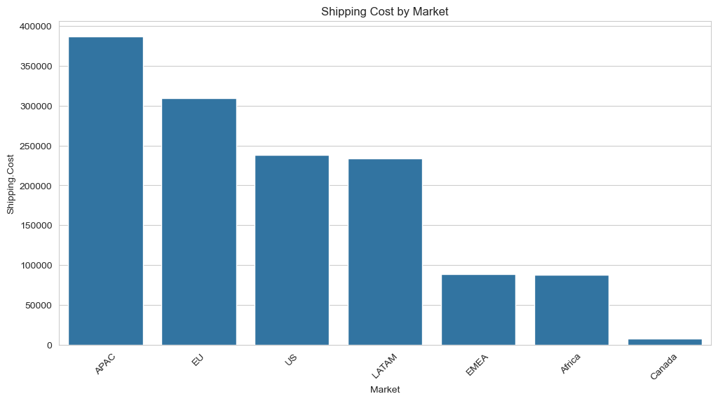
The APAC market generates the highest total shipping costs among all markets.
However, APAC also produces strong sales volumes, meaning that high shipping expenses are partially explained by larger business activity:
Market | Sales | Profit | Shipping.Cost
APAC | 3585833 | 436000.04900 | 387165.1140
EU | 2938139 | 372829.74150 | 309422.3540
US | 2297354 | 286397.02170 | 238173.7904
LATAM | 2164687 | 221643.48708 | 234133.6150
EMEA | 806184 | 43897.97100 | 88375.7300
Africa | 783776 | 88871.63100 | 88139.4700
Canada | 66932 | 17817.39000 | 7405.6300

To better evaluate efficiency, a Shipping Ratio metric was used:
Shipping Ratio = Shipping Cost / Sales
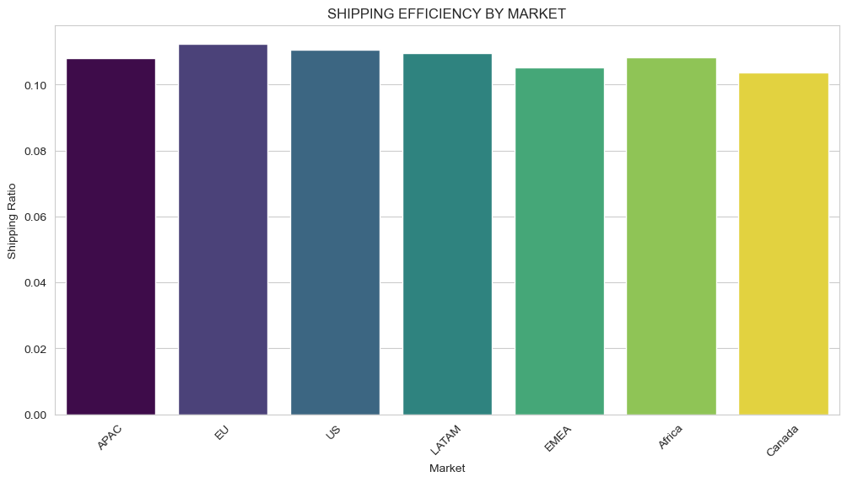
This analysis revealed that some smaller markets (like Canda, Africa and EMEA) experience disproportionately high shipping expenses relative to sales.
In particular, the Canada market appears less operationally efficient because shipping costs are high compared to generated profit.

3. Discount and Profitability Analysis

Discount vs Profit
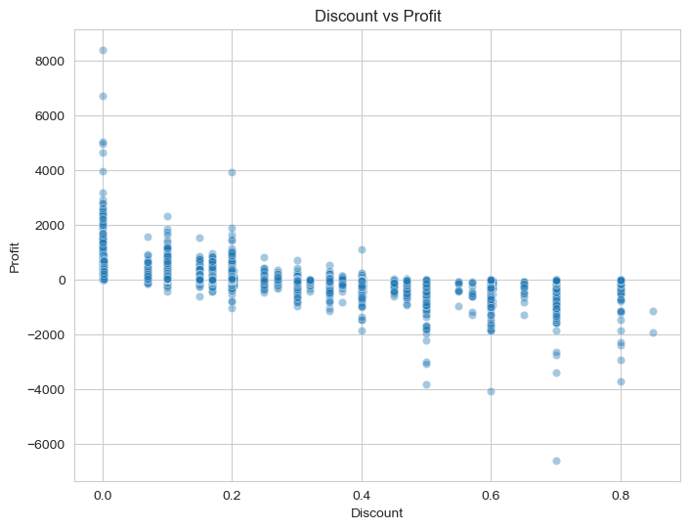
The analysis identified a negative relationship between discounts and profitability.
As discount levels increase, average profit tends to decline significantly.
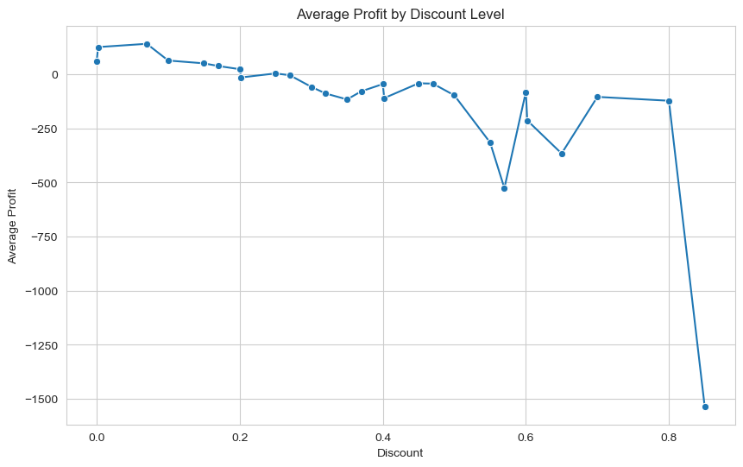
Many high-discount orders generate very low or even negative profit.
These findings suggest that aggressive discount strategies may reduce overall business performance if not carefully controlled.

Discount vs Sales
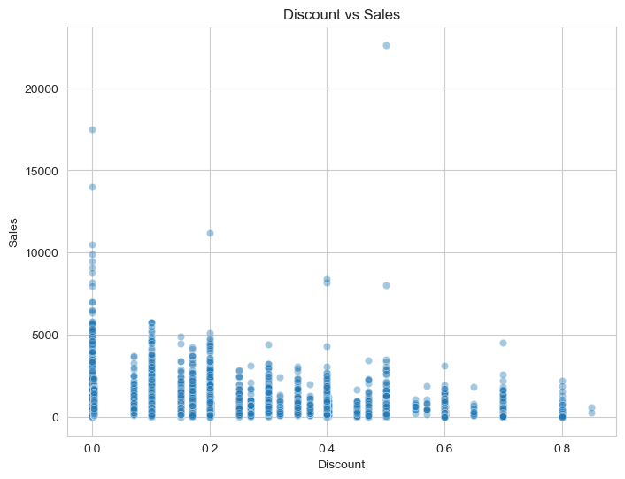
Higher discounts do not consistently produce proportional increases in sales.
Although discounts may stimulate some purchasing activity, the increase in revenue often does not compensate for the reduction in profit margin.
This suggests that discount policies should be optimized to avoid unnecessary profit loss.

4.Shipping Cost and Profit Relationship

Shipping Cost vs Profit
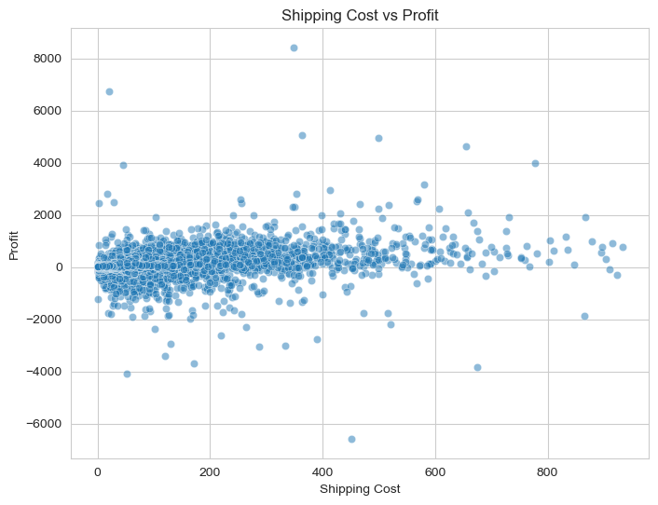
A positive relationship exists between shipping cost and profit.
However, this relationship should be interpreted carefully.
Orders with higher shipping costs are often associated with:
- larger quantities,
- higher sales,
- and naturally higher profit.
Therefore, higher shipping costs do not necessarily improve profitability directly.
Instead, shipping cost appears to scale with overall order size.

Shipping Cost Trend Over Time
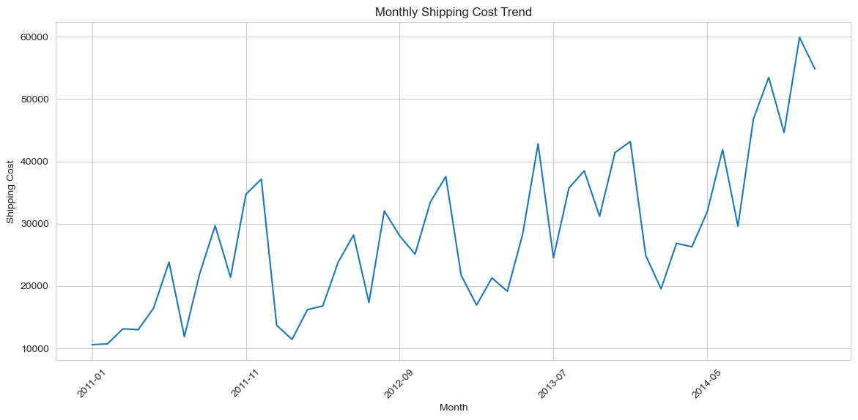
The time-series visualization shows that shipping costs increased noticeably during the later periods of the dataset.
Additional visualizations of monthly sales and order volume also indicate higher business activity during these periods:
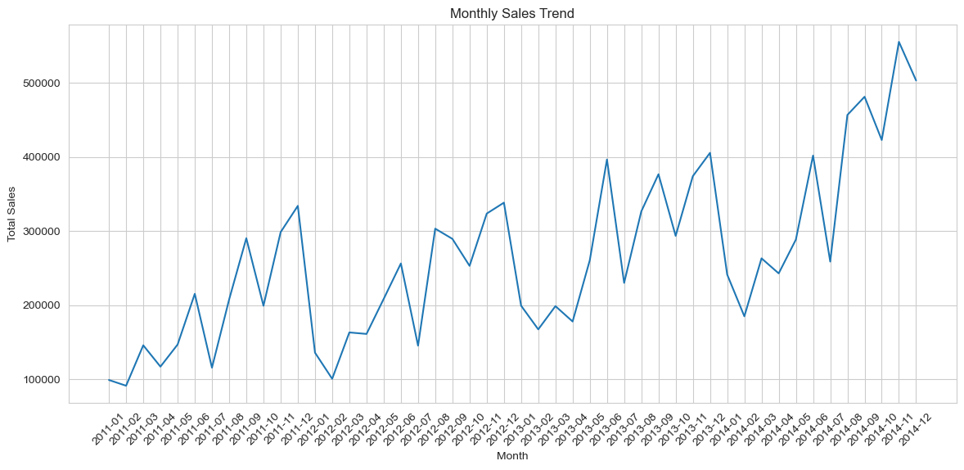
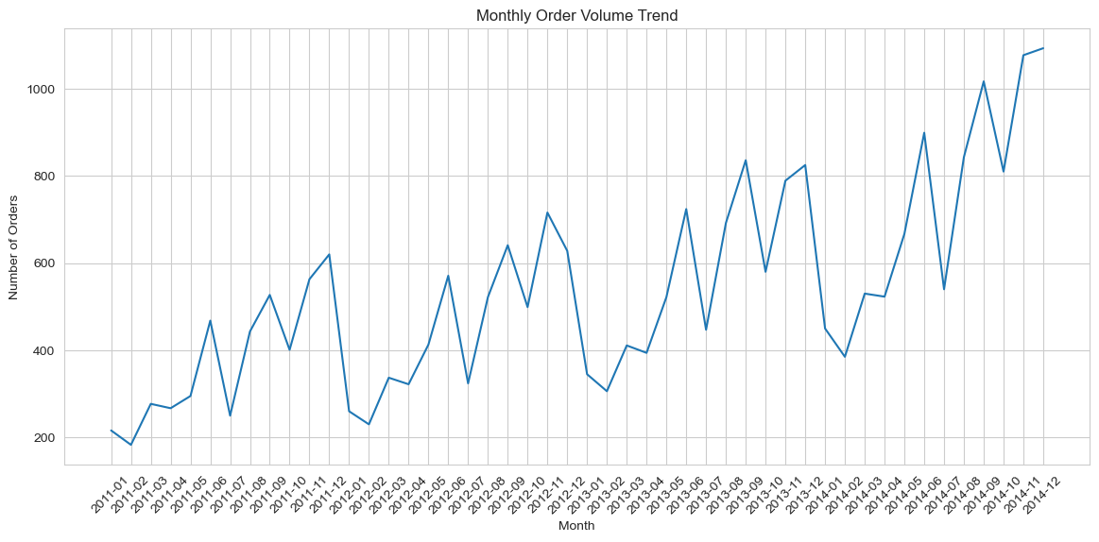
This suggests that the rise in shipping expenses may be partially associated with increased sales performance and transaction volume rather than shipping inefficiency alone.
However, the increase appears more pronounced in the final periods, which may require further operational investigation.

Final Recommendations and Business Answer
The analysis suggests that shipping costs can be optimized without significantly harming profitability if operational strategies are adjusted carefully.

Main Recommendations

1. Prioritize Standard Class Shipping
Standard Class appears to provide the best balance between shipping cost and profitability.
Although premium shipping methods offer faster delivery, they generate substantially higher operational expenses while contributing less overall profit.
Encouraging customers to use Standard Class shipping whenever possible could improve operational efficiency.

2. Review Premium Shipping Operations
Same Day and First Class shipping methods produce significantly higher shipping costs per order.
The company should evaluate:
- whether these services generate sufficient business value,
- and whether their pricing structure adequately covers operational expenses.

3. Optimize Shipping Operations in Inefficient Markets
Some markets, particularly Canada, Africa, and EMEA, show disproportionately high shipping expenses relative to sales and profit.
These markets may benefit from:
- logistics optimization,
- regional warehouse adjustments,
- or revised shipping strategies.

4. Reevaluate Discount Policies
The analysis shows that higher discounts are strongly associated with lower profitability and loss-making orders.
Discount strategies should therefore be applied more selectively, especially for:
- low-margin products,
- expensive shipping regions,
- and orders with already high operational costs.

5. Monitor Low-Value Orders with High Shipping Ratios
Several low-value products generate disproportionately high shipping expenses relative to sales value.
The company could reduce inefficiencies by:
- bundling low-value products,
- introducing minimum order thresholds,
- or adjusting shipping fees for low-value purchases.

Final Business Conclusion
The analysis demonstrates that shipping costs do not necessarily reduce profitability when supported by strong sales performance and efficient operational management.
However, excessive shipping expenses, aggressive discounting, and inefficient regional operations can significantly weaken profit margins.
Overall, the findings suggest that the company can improve profitability by:
- encouraging cost-efficient shipping methods,
- optimizing inefficient markets,
- and applying more controlled discount strategies,
while still maintaining healthy sales performance and customer service quality.

